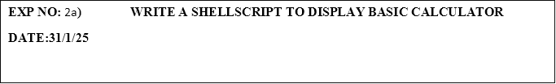

**PROGRAM:**

#!/bin/bash

echo "-------------------------"

echo "   Basic Calculator"

echo "-------------------------"

echo "Enter first number:"

read a

echo "Enter second number:"

read b

echo "Select operation:"

echo "1. Addition (+)"

echo "2. Subtraction (-)"

echo "3. Multiplication (*)"

echo "4. Division (/)"

read choice

case $choice in

  1)

    result=$((a + b))

    echo "Result: $a + $b = $result"

    ;;

  2)

    result=$((a - b))

    echo "Result: $a - $b = $result"

    ;;

  3)

    result=$((a * b))

    echo "Result: $a * $b = $result"

    ;;

  4)

    if [ $b -ne 0 ]; then

      result=$(echo "scale=2; $a / $b" | bc)

      echo "Result: $a / $b = $result"

    else

      echo "Error: Division by zero not allowed."

    fi

    ;;

  *)

    echo "Invalid choice."

    ;;

esac

**OUTPUT:**

-------------------------

Basic Calculator

-------------------------

Enter first number:

5

Enter second number:

4

Select operation:

1. Addition (+)

2. Subtraction (-)

3. Multiplication (*)

4. Division (/)

1

Result: 5 + 4 = 9